Part 1: Campaign Analysis Report

CTI  Framework | Feature / Phase | Extracted Indicator / Detail (The "What") | Analytical Purpose (The "Why" in CTI)
CAMPAIGN NAME & GitHub report direct link Campaign Name: APT28 - DRAGONFISH Delivers New Form of Elise Malware Targeting ASEAN Defense Ministers' Meeting
GitHub Link: APT28.pdf
DM:  Adversary | Actor/Group Name | APT28 - DRAGONFISH (also known as Lotus Blossom / Spring Dragon). The actors previously focused campaigns on Southeast Asia, targeting high-profile government, military, political, education, and telecommunication institutions. | Establishes intent and motive (Strategic).
DM:  Capability | Primary Malware Hash  / Tool Name | Malware Name: New form of Elise malware.  Primary DLL Hash (NavShExt.dll): cd36bbd7f949cf017edba0e6aaadf28c (MD5).  Unique Mutex: donotbotherme. | Establishes the technical fingerprint (Hunting).
DM:  Infrastructure | PRIMARY C2 DOMAIN / IP | 103.236.150.14  (Hardcoded real C2 server). | Defines the first pivot point for the investigation.

DM:  Infrastructure | FAILOVER  C2 / Unique ASN | The malware attempts to spoof the host and query non-existing domains (e.g., 3qyo4o7.7r7i3[.]info, dtdf5vu.nt7yq[.]info). No specific operational failover IP or ASN is mentioned in the sources. | Defines the adversary’s redundancy and strategic scope.
CKC:  Delivery | Initial Vector | Spear-phishing via a malicious Microsoft Word document with a malicious executable embedded as an OLE object. Execution occurs by exploiting the CVE-2017-11882 vulnerability. | Defines the perimeter defense failure point.
CKC:  Installation | Persistence Mechanism | Persistence is achieved using the Run Registry key.  The specific location/value is HKCU\Software\Microsoft\Windows\CurrentVersion\Run\IAStorD. | Defines the endpoint defense requirement.
CoA:  Tactical | Immediate Action | Block the Primary C2 IP (103.236.150.14) at the firewall. Patch the CVE-2017-11882 vulnerability by installing Microsoft Security Update KB2553204. | The reactive step to break the current chain.
CoA:  Strategic | Proactive Action | Inform hunting activities by adding IoCs to hunting lists or EDR solutions. Specifically, look for the following artifacts: the mutex handle named donotbotherme, a value named IAStorD in the autorun key, the log file FXSAPIDebugLogFile.tmp, and the data storage file thumbcache_1CD60.db. | The anticipatory step to manage the entire campaign.

Part 2: Analysis of Maltego Output: DRAGONFISH C2 (103.236.150.14)

The Maltego visualization successfully executed the required vertical pivots on the primary DRAGONFISH Command and Control (C2) IP.

Vertical Pivot Confirmation: The public IP address 103.236.150.14 is located in Karet Kuningan, Jakarta, 12940, Indonesia. It is assigned to the ISP “PT Inovasi Global Mumpuni”. The address belongs to ASN (Autonomous System Number) 55664 which is delegated to PT Inovasi Global Mumpuni. The secondary confirmed IoC, the existence of the fake logging file (FXSAPIDebugLogFile.tmp) and the unique mutex (donotbotherme), resolves successfully to the malware signature (MD5 cd36bbd7f949cf017edba0e6aaadf28c), confirming the strategic origin of the threat is the Elise malware variant.

Horizontal Pivot: Threat actors are either using the IP address directly without a domain name and utilizing a rapidly disposable domain (like the spoofed 3qyo4o7.7r7i3[.]info mentioned in the report).
IP-to-Domain / Reverse DNS: All horizontal pivots using generic OSINT tools (IP to domain, IP to subdomains) failed to return any malicious domain names.

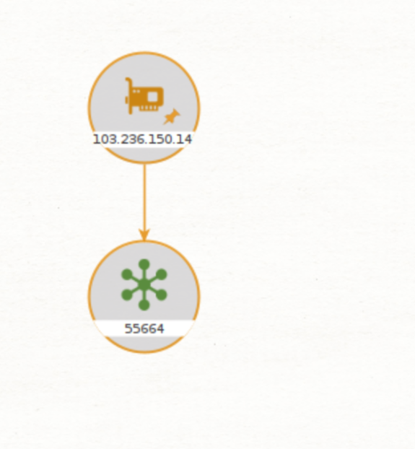

Part 3: Final Analytical Summary: DRAGONFISH (Lotus Blossom) Campaign

CKC vs. DM Utility: The analysis of the DRAGONFISH campaign demonstrates the complementary utility of the CKC and the Diamond Model (DM) in cyber defence. The CKC defined the timing of tactical defence—for example, during the Delivery phase (Spear-phishing with a malicious attachment exploiting CVE-2017-11882), defenders can patch known exploits and block the Primary C2 IP (103.236.150.14) before command execution.

In contrast, the DM defined the scope of strategic defense. By identifying the Adversary as the state-sponsored DRAGONFISH (Lotus Blossom), the strategic focus expanded from simple containment to proactive defense, including application whitelisting, netblock monitoring, and AS Number-level blocking to mitigate future threats.

Managing multiple chains: is achieved by pivoting from a single IoC. The Vertical Pivot (running IP-to-AS Transforms in Maltego) reveals the infrastructure’s physical scope (e.g., AS55664), while the Horizontal Pivot (Netblock scanning) uncovers redundant assets within the same range (103.236.150.0/24). Strategically blacklisting the entire AS Number (AS55664) and related Netblocks proactively disrupts the adversary’s full infrastructure, collapsing the campaign’s access layer.

CTI Lesson: Aggregation and pivoting transform a single IoC (103.236.150.14) into actionable strategic intelligence, shifting defence from reactive patching and file removal to pre-emptive campaign disruption and threat actor profiling.

